Uwin Technologies Co., Ltd
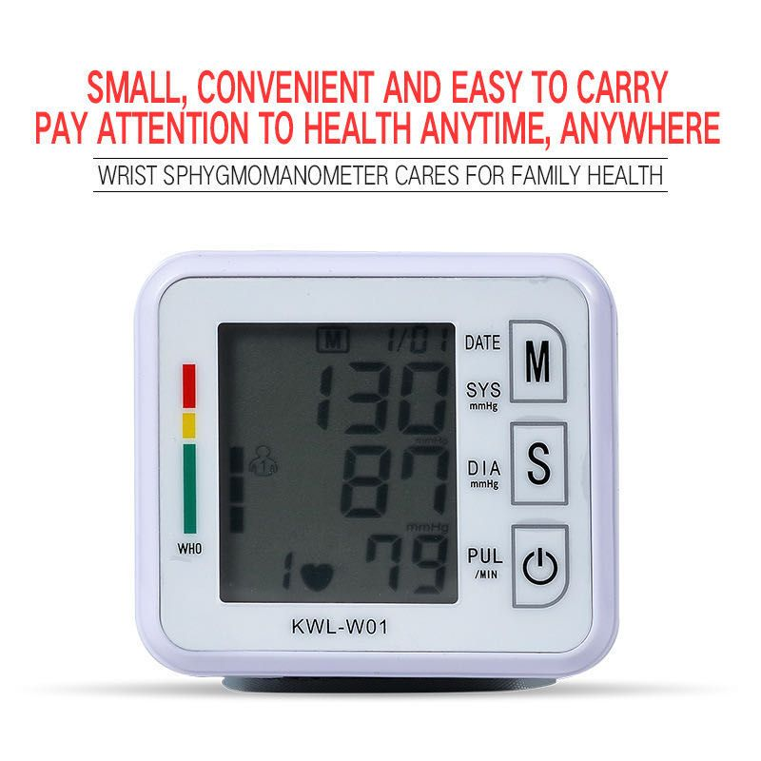
Features:
Clock function, you can set year, month, day, hour, minute by yourself easily.
Arm type of design, you need to take off your coat or your sweater for measuring accurately.
Intelligent pressurize and decompress design, with IHB heart rate monitoring function, more practical.
LCD display ensures clear numbers for the elderly and you can see the systolic pressure, diastolic pressure and pulse easily.
The Systolic pressure and diastolic pressure separately show people can judge the data whether in the normal range at first sight.
Larger memory storage and irregular heartbeat detection, remind irregular heartbeat and show average measurement of the last three times.
COLOR:WHITE
Package weight:313g
Package size:14cmx10cmx 9cm

